11.1.10 Editors - Compositor Editor - Header - Add Menu - Vector
Detailed table of content 1
Add menu - Vector 2
Map Range Node 2
Map Value 3
Normal 4
Normalize 4
Vector Curves 5

Detailed table of content
Detailed table of content
Detailed table of content 1
Add menu - Vector 2
Map Range Node 2
Usage 2
Inputs 3
Value 3
From Min/Max 3
To Min/Max 3
Properties 3
Clamp 3
Outputs 3
Value 3
Map Value 3
Inputs 3
Value 3
Properties 3
Offset 3
Size 3
Use Minimum, Maximum 3
Min, Max 3
Outputs 4
Value 4
Normal 4
Inputs 4
Normal 4
Properties 4
Normal Direction 4
Outputs 4
Normal 4
Dot 4
Normalize 4
Inputs 4
Value 4
Outputs 5
Value 5
Vector Curves 5
Inputs 5
Vector 5
Properties 5
Channel 5
Channel buttons 5
Curve edit field 5
Selecting Points 5
Adding Points 5
Navigation elements 5
Zoom in and out 5
Tools 6
Reset View 6
Vector Handle 6
Auto Handle 6
Auto Clamped Handle 6
Extend horizontal 6
Extend extrapolated 6
Reset Curve 6
Use Clipping 6
Delete Points 6
Outputs 6
Vector 6

Add menu - Vector
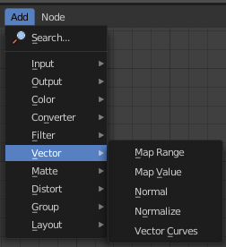
Here you find nodes that deals with vector data.

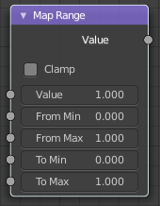
Map Range Node
This node allows to convert (map) an input value range into a destination range. By default, values outside the specified input range will be proportionally mapped as well. This node is similar to Map Value node but provides a more intuitive way to specify the desired output range.

Usage
One important use case is to easily map the original range of the Z-depth channel to a more usable range (i.e: 0.0 - 1.0) for use as a matte for colorization or filtering operations.

Inputs

Value
Standard value input.

From Min/Max
Start/End of the input value range.

To Min/Max
Start/End of the destination range.

Properties

Clamp
Clamps values to Min/Max of the destination range.

Outputs

Value
Standard value output.

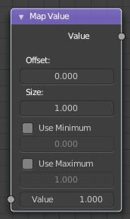
Map Value
Map Value node is used to scale, offset and clamp values.

Inputs

Value
Standard Value input. (Value refers to each vector in the set.)

Properties

Offset
Factor added to the input value.

Size
Scales (multiply) the input value.

Use Minimum, Maximum
Enable this to activate their related operation.

Min, Max
Defines a range between minimum and maximum to clamp the input value to.

Outputs

Value
Standard value output.

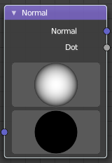
Normal
The Normal node generates a normal vector and a dot product.

Inputs

Normal
Normal vector input.

Properties

Normal Direction
To manually set a fixed normal direction vector. LMB click and drag on the sphere to set the direction of the normal. Holding Ctrl while dragging snaps to 45 degree rotation increments.

Outputs

Normal
Normal vector output.

Dot
Dot product output. The dot product is a scalar value.

If two normals are pointing in the same direction the dot product is 1.
If they are perpendicular the dot product is zero (0).
If they are anti parallel (facing directly away from each other) the dot product is -1.

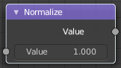
Normalize
Find the minimum and maximum values of a single channel. Then map the values to a range of 0 and 1.

Inputs

Value
Standard value input.

Outputs

Value
Standard value output.

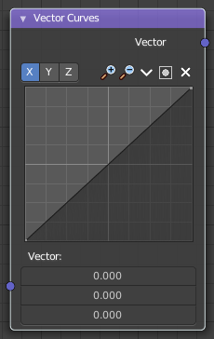
Vector Curves
The Vector Curves node maps an input vector components to a curve.

Inputs
In the shader context the node also has an additional Factor property.

Vector
Standard vector input.

Properties

Channel

Channel buttons
X, Y, Z. Clicking on one of the channels displays the curve for each.

Curve edit field
Create and tweak a Bezier curve that varies the input levels (X axis) to produce an output level (Y axis).


Selecting Points
You can select curve points. This reveals two edit boxes for the x and y coordinate of this point.
Selected points can be moved around. Left click at them, hold the mouse button down and move them to a new location.


Adding Points
You can add new curve points by simply left clicking at the curve. Move the mouse to position them where you need it.

Navigation elements
The navigation elements at the top are described from left to right.

Zoom in and out
The two buttons with the magnifying glass at it zooms in and out in the curve window.

Tools

Tools is a menu where you can find some curve related tools.

Reset View
Resets the curve windows zoom.

Vector Handle
Set handle type to Vector.

Auto Handle
Set handle type to Auto.

Auto Clamped Handle
Set handle type to Auto Clamped.

Extend horizontal
Extends the curve before the first curve point and behind the last curve point horizontally.

Extend extrapolated
Extends the curve before the first curve point and behind the last curve point extrapolated.

Reset Curve
Resets the curve to the initial shape.


Use Clipping
Clipping options. Set up clipping for the stroke.

Delete Points
Deletes selected curve points.

Outputs

Vector
Standard vector output.

